Atul Jha

110350053

CSE 527 Homework 2

1.

Step 1:

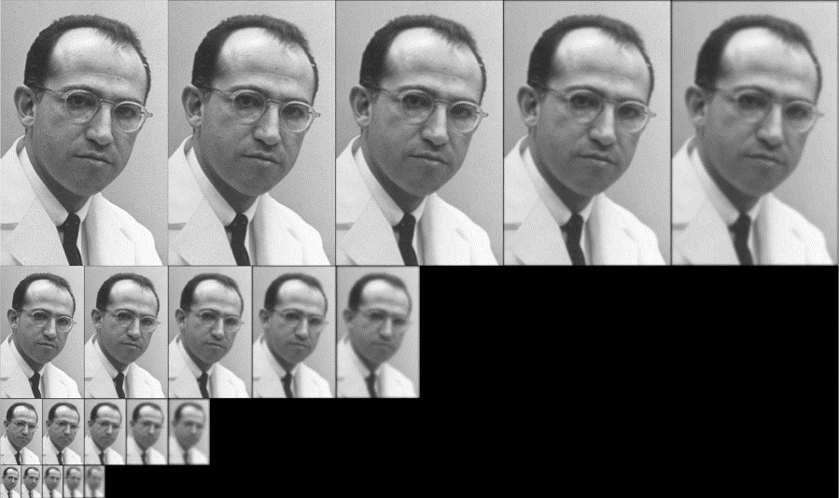

Gaussian Pyramid

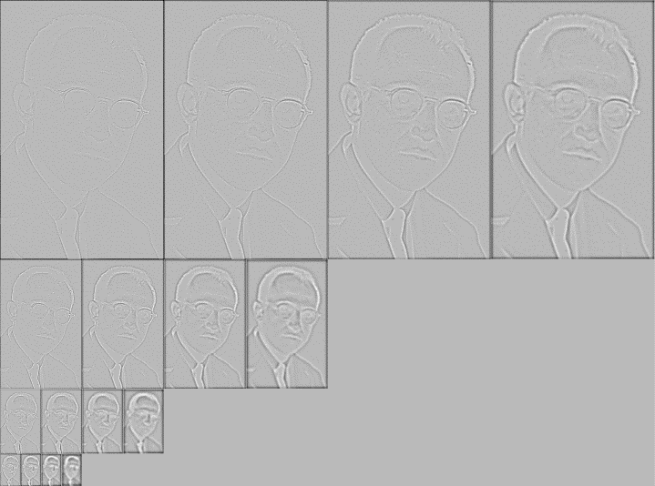

DOG Pyramid

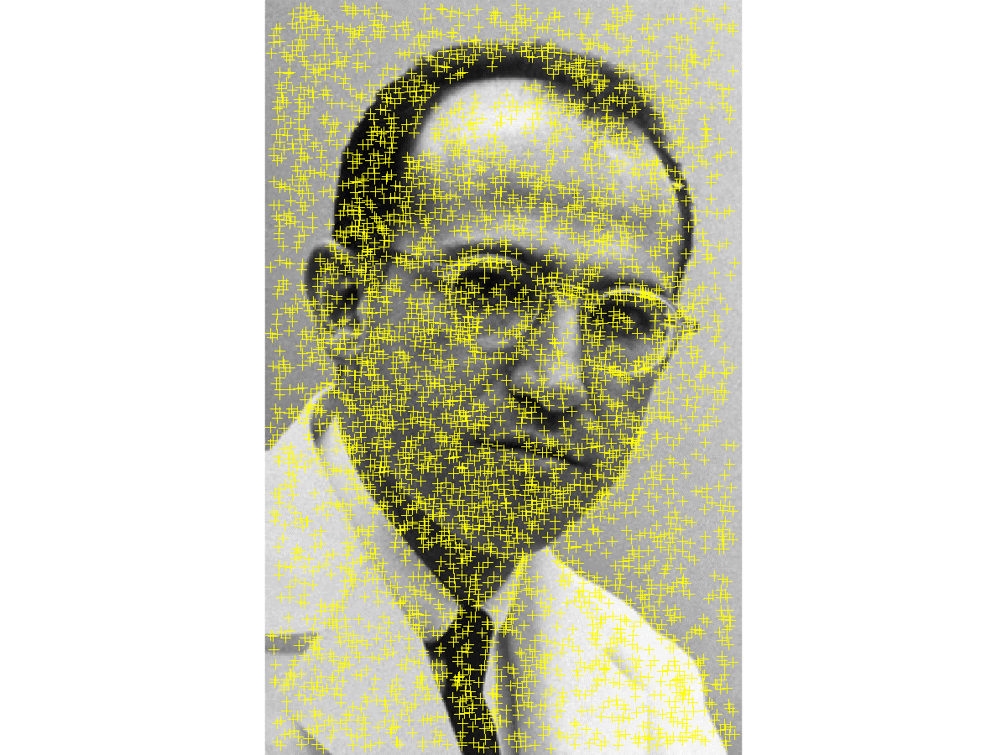

DOG Extrema

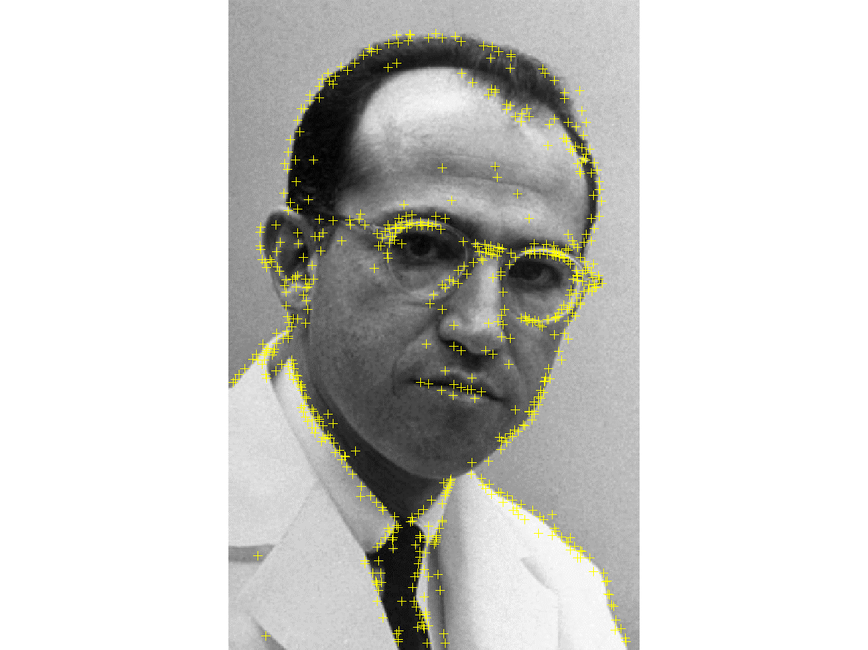

Keypoints after removing low contrast extrema

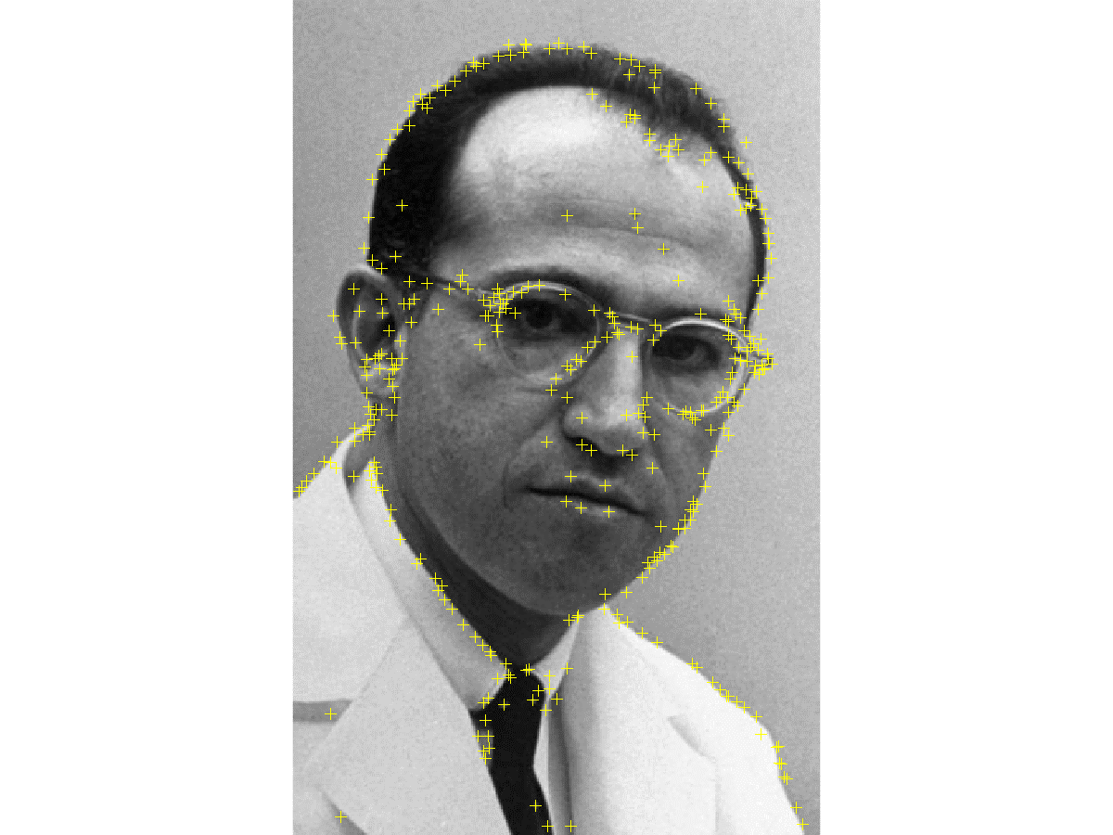

Keypoints after removing edge points using principal curvature filtering

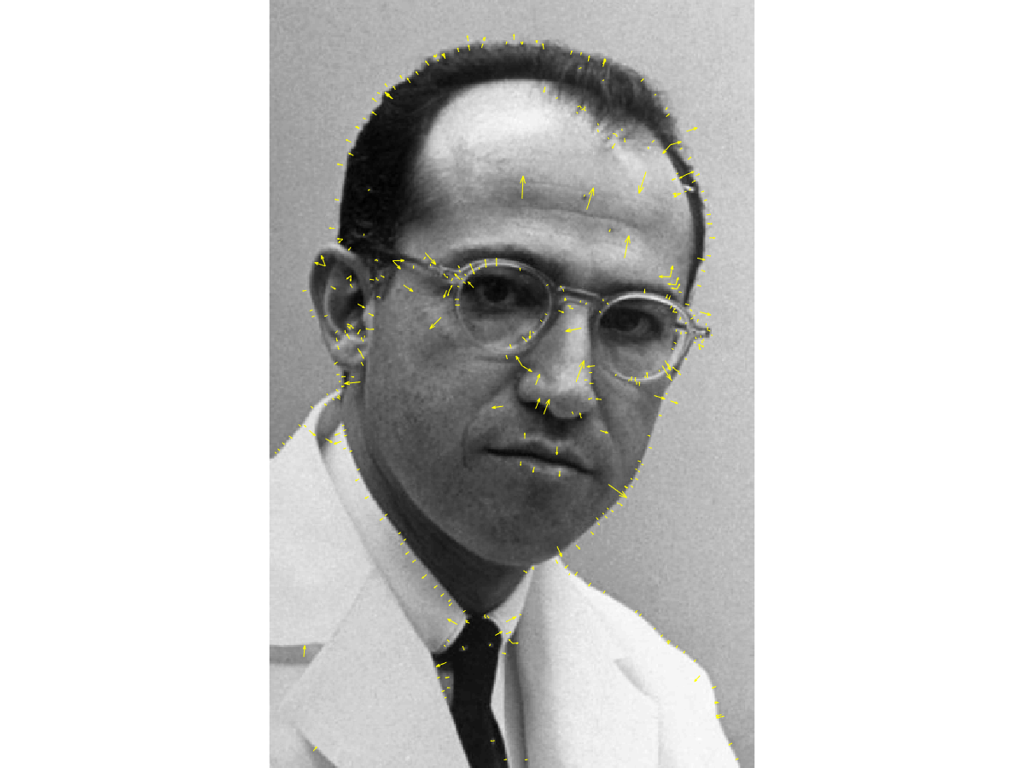

Final keypoints

Step 3:

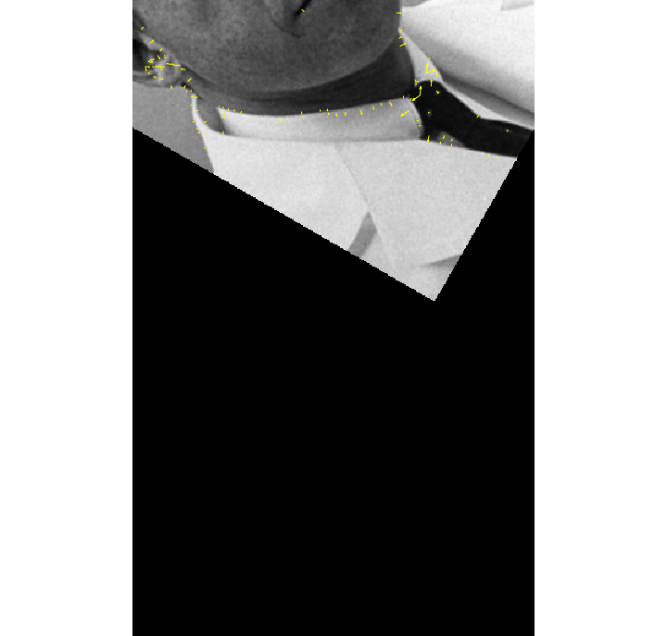

Final keypoints

Affine Matrix:

0.5000 -0.8660 100.0000

0.8660 0.5000 200.0000

0 0 1.000000

Step 6:

Affine Matrix Calculated

0.4998 -0.8632 99.79960

0.8652 0.5026 199.8163

0 0 1.000000

2.

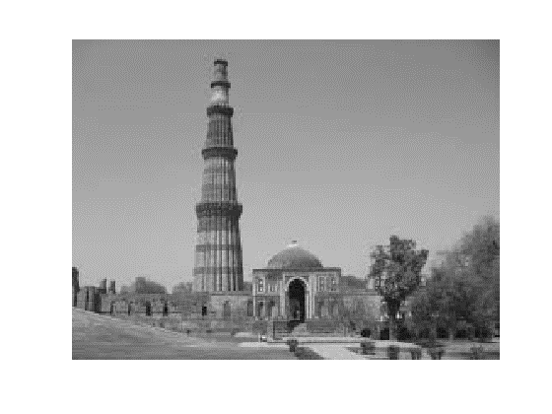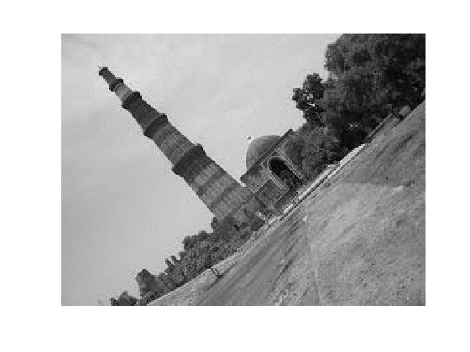

Original Reference

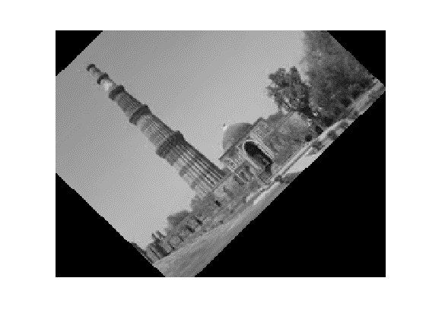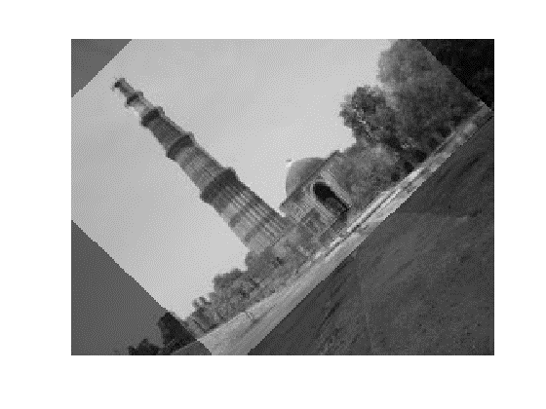

Aligned Fused

Affine Matrix:

0.7832 -0.8220 92.8190

0.7152 0.7324 -26.7111

0 0 1.00000

3.

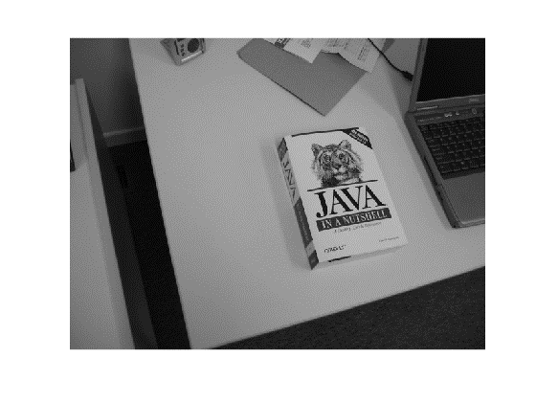

Object Image Aligned Image

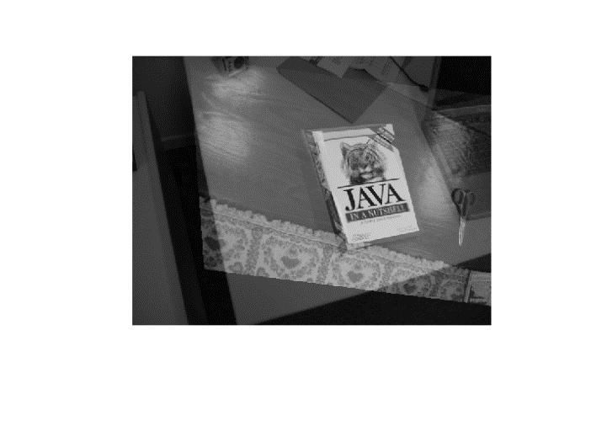

Fused Image

Affine Matrix:

-1.1490 0.0828 756.5938

0.1624 -1.2792 467.0977

0 0 1.000000

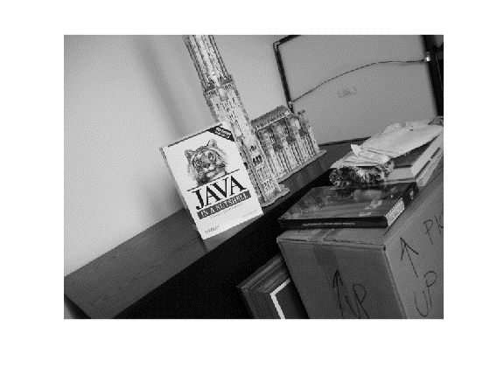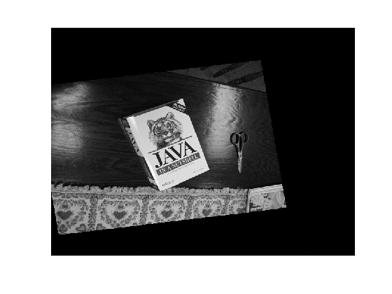

Object Image Aligned Image

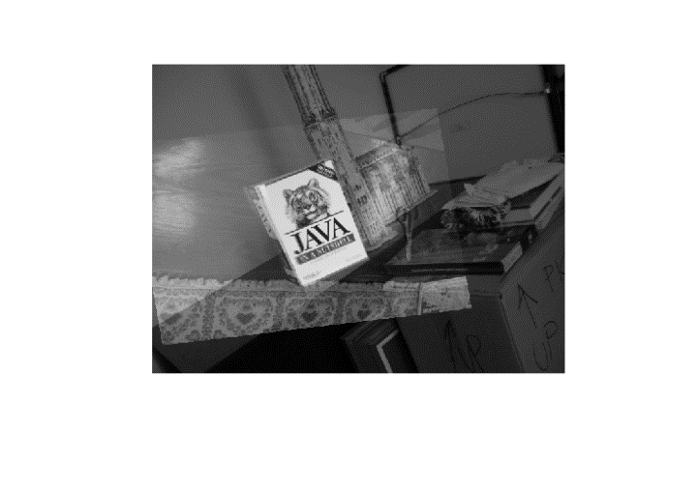

Fused Image

Affine Matrix:

-1.3065 0.2254 563.3894

-0.1793 -1.5063 661.9360

0 0 1.000000

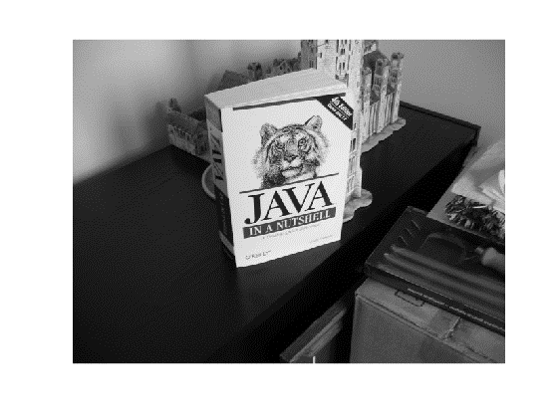

Object Image Aligned Image

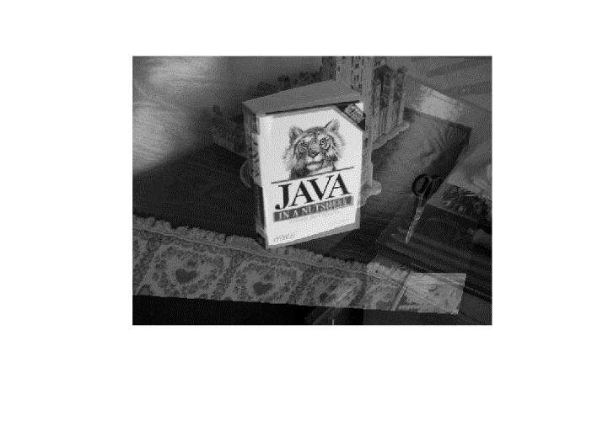

Fused Image

Affine Matrix:

-0.9229 -0.2070 631.3198

0.0636 -1.0480 447.5176

0 0 1.000000

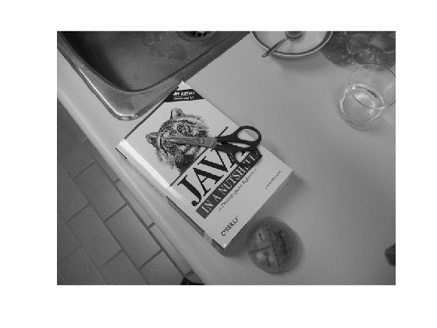

Object Image Aligned Image

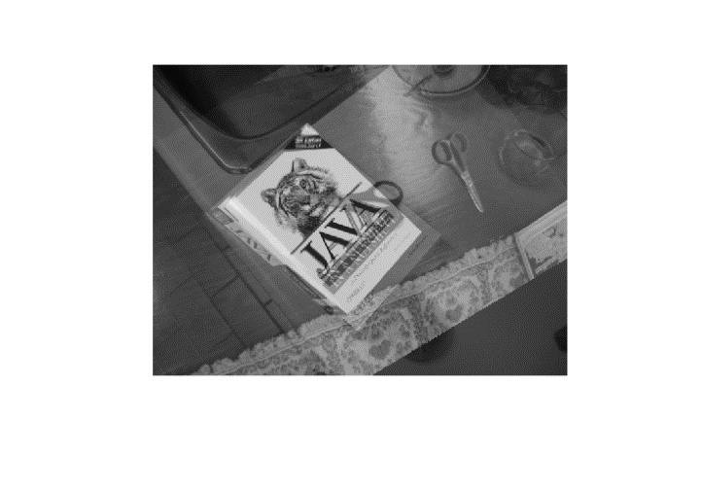

Fused Image

Affine Matrix:

-0.7131 0.5081 359.2872

-0.5131 -0.8564 586.1217

0 0 1.0000

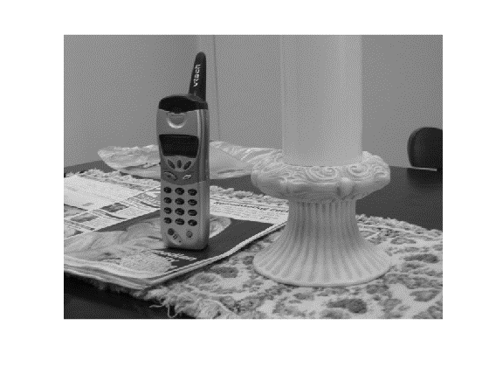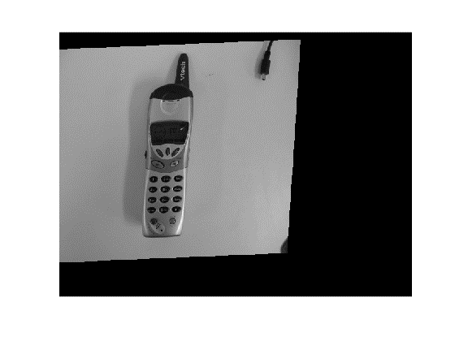

Object Image Aligned Image

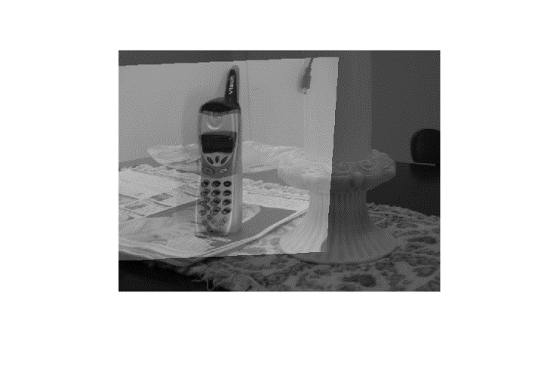

Fused Image

Affine Matrix:

1.5047 -0.0042 32.4012

-0.0924 1.3642 -39.1067

0 0 1.00000

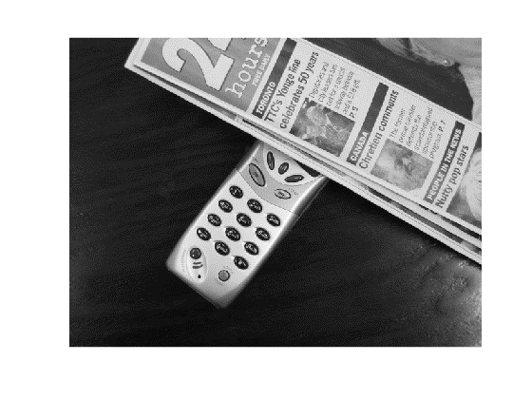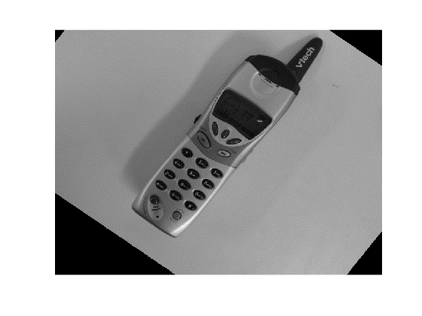

Object Image Aligned Image

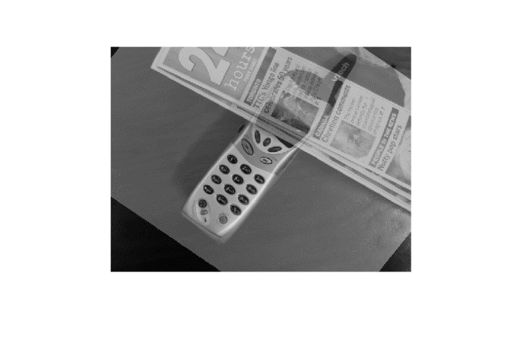

Fused Image

Affine Matrix:

0.6826 0.5472 -13.06050

-0.4761 0.7004 256.0867

0 0 1.000000

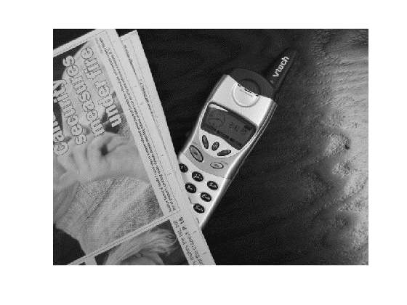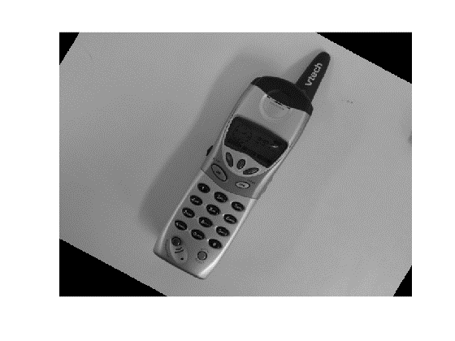

Object Image Aligned Image

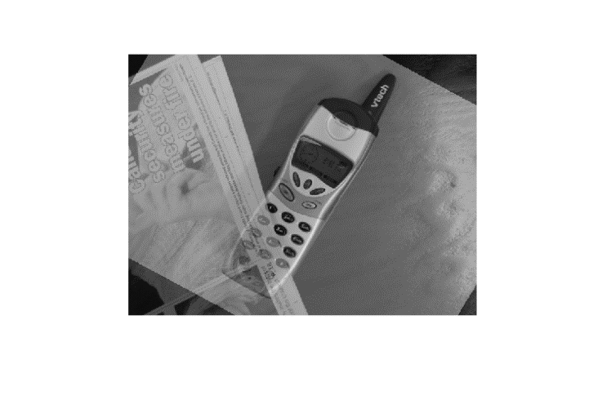

Fused Image

Affine Matrix:

0.7430 0.4516 -27.0637

-0.4122 0.7684 192.2528

0 0 1.000000

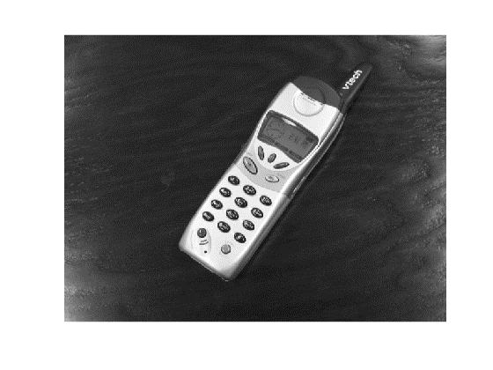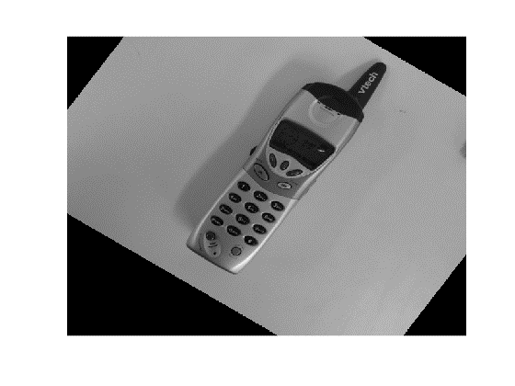

Object Image Aligned Image

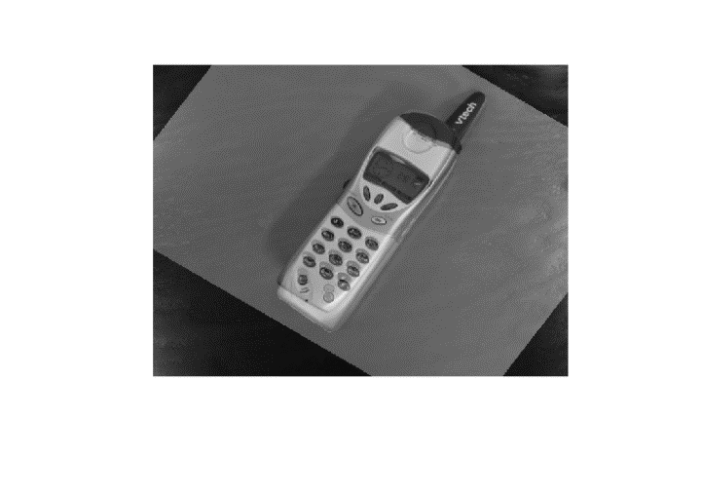

Fused Image

Affine Matrix:

0.7801 0.6036 -70.8192

-0.4969 0.8581 236.0779

0 0 1.000000